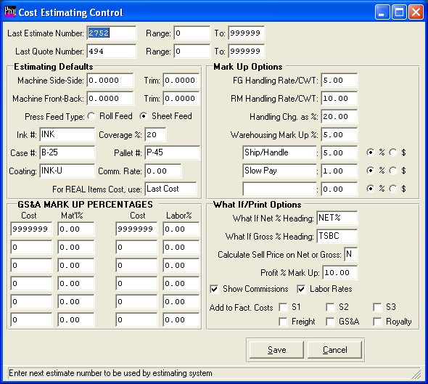

CONTROL FILE

The Control file establishes default criteria that is transferred to the estimate when adding a new estimate and also used while calculating and printing an estimate. Costs such as commissions, handling charges, material costs, etc. may be set up in this file so that the calculation is automatic when printing an estimate. The cost figures normally do not change from one estimate to the next; however, the information may be modified for each estimate if necessary.

Next Estimate Number - (6) numeric digits. Enter the starting estimate number. The system will automatically add one thereafter.

Range: - Two (6) numeric digit fields. Enter valid range of estimate numbers. Different plants within the same company may have different range of quote numbers.

Next Quote Number - (6) numeric digits. Enter the starting quote number. The system will automatically add one thereafter.

Range: - Two (6) numeric digit fields. Enter valid range of quote numbers. Different plants within the same company may have different ranges of quote numbers.

Show Labor Rates on estimate? - (1) alpha character. Enter "Y" for yes or "N" for no to display labor rates on all estimates.

Round Dollars on Estimates? - (1) alpha character. Enter "Y" to round cents up to nearest .99 on the estimate print out.

Layout Sheet Width - (8) numeric digits with four decimals. This defaults to the estimate, but may be changed to calculate a new layout, die size and sheet size.

Feed - Enter the default printing press feed type. Enter S for sheet or R for roll. This works with the layout size. For offset presses, an S causes the board length to run across the width of the machine for die size calculation.

Layout Sheet Length - (8) numeric digits with four decimals. This defaults to the estimate, but may be changed to calculate a new layout, die six and sheet size.

Feed - Enter the default printing press feed type. Enter S for sheet or R for roll. This works with the layout size. For offset presses, an S causes the board length to run across the width of the machine for die size calculation.

Trim Width - (5) numeric digits with two decimals. This dimension increases the die size width in calculating the sheet width for all board grades. If a layout machine is entered on the estimate, the machine's trim dimensions from the machine file are used.

Trim Length - (5) numeric digits with two decimals. This dimension increases the die size length in calculating the sheet length for all board grades. If a layout machine is entered on the estimate, the machines trim dimensions from the machine file are used.

Default Ink # - (10) alpha numeric characters. To speed estimating, this material item number will transfer to each new estimate if not defined in the style file. When the numbers of colors are entered on the estimate, this item number will be duplicated by the amount of colors.

Default Ink Coverage % - (3) numeric digits. To speed estimating, this coverage percentage automatically transfers to each color on the estimate. Alternatively, an ink may be assigned for each style.

Default Coating (10) alpha numeric characters. To speed estimating, this coating item number will transfer to each new estimate if not defined in the style file. When the number of coatings are entered on the estimate, this coating number will repeat for the number of coating entered. This may be changed.

Default Case # - (10) alpha numeric characters. To speed estimating, this material transfers to each estimate if not defined by style. The number of cases required is calculated by either case count or by weight per case, as defined in the cases raw material record. Given the case count, the estimate quantity is divided by the case count. Alternatively, if we use weight per case, the system calculates the total shipping weight for the run quantity and divides by the weight per case. Given the number of cases, the program finds the cost per case in the case materials matrix and multiplies by the total number of cases.

Default Pallet # - (10) alpha numeric characters. To speed estimating, this material item transfers to each estimate if not defined by style. If a case number is entered, the number of pallets is calculated as dictated by the cases per pallet in the materials case record. The system calculates the total number of pallets and multiplies by the cost per pallet. If the cases per pallet is zero on the estimate, the number of pallets will be calculated by the Weight per Pallet. For freight calculations, a pallet weighs 50 pounds.

LBS/Pallet - (8) numeric digits with 2 decimals. If the number of cases per pallet on the estimate is zero, then the total number of pallets required is calculated by dividing the total shipping weight by the weight per pallet.

FG Handling Rate/CWT - (6) numeric digits with two decimals. You may leave blank or enter a mark up percentage for finished goods handling, as a rate per hundred weight, to multiply by the total weight of materials divided by 100. This cost is added to labor cost.

RM Handling Rate/CWT - (6) numeric digits with two decimals. You may leave blank or enter a mark up percentage for raw materials handling, as a rate per hundred weight, to multiply by the total weight of material divided by 100. Handling Charge as % - (6) numeric digits with two decimals. As an alternative or in addition to the finished goods and raw materials markup per CWT, this mark up percentage is multiplied by total material cost of materials. This cost is added to the labor cost.

Warehousing Mark Up % - (6) numeric digits with two decimals. This percentage is multiplied by total cost to calculate warehousing cost. This cost is added to the total factory cost.

Commissions Mark Up % - (6) numeric digits with two decimals. Enter the percentage to multiple by total cost to calculate commissions for an estimate if not defined in the salesman file. Commissions set up in the salesman file may be established by customer, customer type and category. This cost is added to the full cost.

Special Markup - (20) alpha characters. Enter up to three user defined descriptions for a miscellaneous markup, to add to the cost of the estimate.

Markup $ / % - (6) numeric digits with two decimals. Enter either the fixed dollar amount or the percentage for the special markup. As an example, to add 10 %, enter .10. Any amount entered greater than 1.00 will be considered a dollar amount.

Ave/Last? - (1) alpha characters. Enter "A" for average cost or "L" for last cost. For stocked material entered on the estimate, this defines which cost to use for calculating the cost of materials.

Mat'l Up to Cost - (7) numeric digits. Enter the material cost in dollars for each cost level break. General selling and administration burden percentages may vary depending on the total cost of the materials for each estimate. Hence, smaller quantities should have higher percentage markups than larger estimate quantities. This matrix should be in ascending order. I.E. lowest quantity first and last quantity set to 9999999.

Mat'l Pct - (5) numeric digits with two decimals. The GS&A material percentage rate is based on the total cost of material for an estimate. Once the cost is calculated, the percentage found in this matrix is multiplied by the material cost.

Labor Up to Cost - (7) numeric digits. Enter the labor cost in dollars for each cost level break. General selling and administration burden percentages may vary depending on the total cost of labor for each estimate. Hence, smaller quantities should have higher percentage markups than larger estimate quantities. This matrix should be in ascending order. I.E. lowest quantity
first and last quantity set to 9999999.

Labor Pct - (5) numeric digits with two decimals.The GS&A labor percentage rate is based on the total cost of labor for an estimate. Once the cost is calculated, the percentage is found in this matrix.

What If Net % Heading - (6) alpha numeric characters. This is a user defined net profit percent heading for the what if analysis screen.

What If Gross % Heading - (6) alpha numeric characters. This is a user defined gross profit percent heading for the what if analysis screen.

Calculate Sell Price on N/G ? - (1) alpha character. Enter "N" for net profit percent or "G" gross profit percent to calculate the selling price per thousand. If "G" is entered, the Profit % mark up below is divided into the total factory cost, which includes direct materials and labor. If "N"
is entered, the Profit % Mark Up below is divided by the Full Cost, which includes all costs. Please note, special labor operations and materials are not included in factory or full cost if the SIMON code on the estimate is "S" for separately bill, "O" for other cost markup charge outside factory, or "N" for No charge.

Profit % mark up - (6) numeric digits with two decimals. This is the percentage of mark up for calculating selling price. The system calculates a divisor (1- (profit % / 100) to calculate sell price.

Show Commissions on Estimate? - (1) alpha character. Enter "Y" for yes or "N" for no to determine whether commissions are printed on estimate and to the total factory cost.

Add Freight to Factory Cost? - (1) alpha character. Enter "Y" for yes or "N" for no to add freight cost to factory cost. If yes, then freight would be marked up by Material GS&A percentages. If "N", then freight is be listed as a separate line item in the totals section of the estimate and added to factory cost.

Add Freight to S1, S2, S3, GSA, Commission? - (1) alpha character. Enter "Y" for yes or "N" for no to add other special markups to factory cost. If yes, then the cost of this markup will be included in factory cost. If "N", then the special costs will be added to the full cost.

